FISHERIES SCIENCE I

Endocrine physiology

Gincy C George
(Assistant Professor On Contract)

Endocrine glands
- Endocrine system act as along with Nervous system
- Secrete hormones to regulate physiological and metabolic processes
- 3 types
* steroid- testosterone, *peptides- insulin, *catecholaminesepinephrine
- Hormones is secreted in to blood, distributed all over the body and the action is only on the target organ
- It is a heterogeneous collection of organs
- Pituitary gland
- Thyroid gland
- Adrenal gland
- Corpuscles of stannius
- Ultimobranchial gland
- Urohypophysis
- Pancreatic islets
- Pineal organ
- Sex organ
- Intestinal mucosa

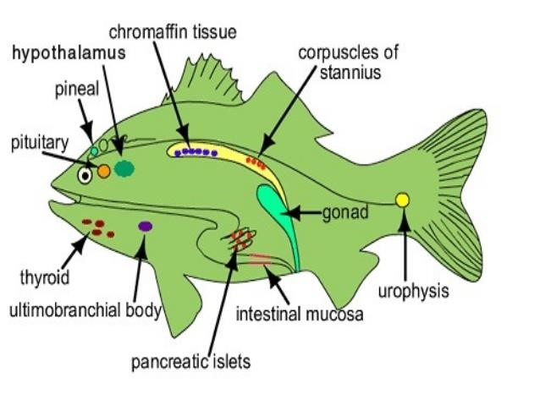

1.Pituitary gland or hypophysis
- Location- ventral surface of brain, below optic chiasma
- Derived from 2 different components
- Neurohypophysis- from the floor of the embryonic diencephalon
- Adenohypophysis- from the dorsal evagination of the ectodermal part of the buccal cavity- Rathke’spouch
- This pouch later loses its connection from the buccal cavity and remains permenantly connected to the neurohypophysis- infundibular stalk or neurohypophysial stalk- connection to the diencephalon
- Stella tunica – shallow depression in the sphenoidal area which protect ventral side of hypophysis

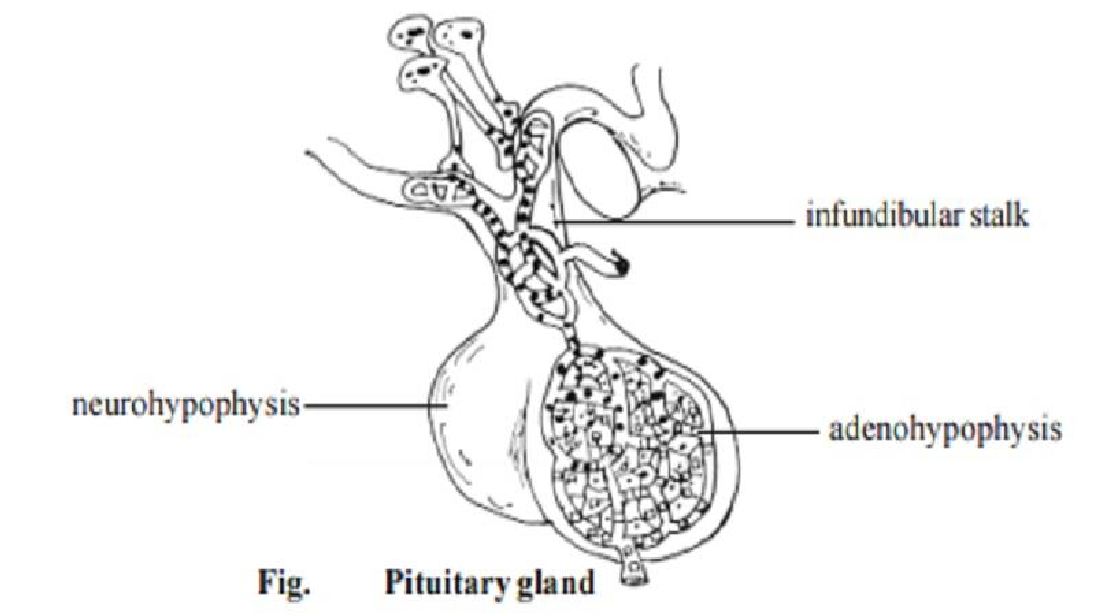

structure
- Adenohypophysis- glandular part
- Neurohypophysis- neural part
AHP further divided into
- Rostral pars distalis (RPD) or pro adenohypophysis- dorsal
- Proximal pars distalis (PPD) or meso adenohypophysis – in between
- Pars intermedia (PI) or meta adenohypophysis – distal end
NHP further divided into
1.Median eminence
2. Posterior pars nervosa

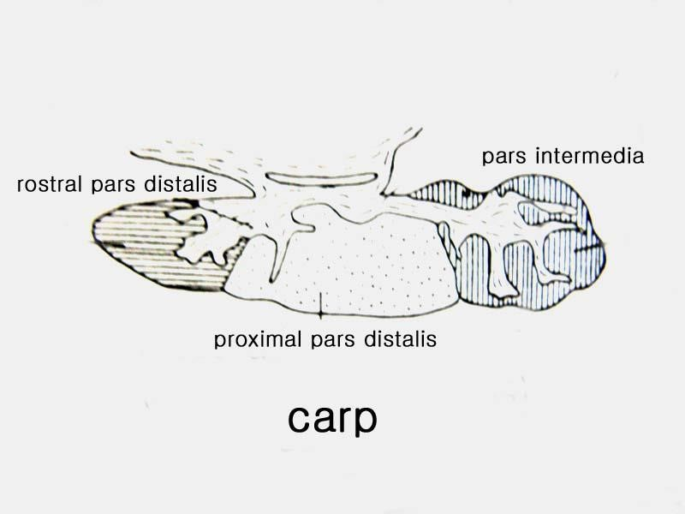

Rostral pars distalis
- Anterior , smallest part of the AHP
- Made up of acidophilic cells- chromophils and cyanophils
- Some cells with non-granular cytoplasm which do not take any stain – chromophobes
- Most of them show follicular arrangement around the blood capillaries
- Functionally 2 type cells – corticotrophs (ACTH) and lactotrophs (prolactin)

Proximal pars distalis
- Middle region , largest part
- Consist of acidophilic , cyanophilic and chromophobic cells
- No. of acidophilic cells reduce significantly during the spawning phase
- 2 type cyanophilic –small and large
- Functionally 3 type cells- thyrotrophs- thyrotrophins, gonadotrophsgonadotrophins, somatotrophs- growth hormones

Pars intermedia
- Posterior end
- Composed of acidophilic , cyanophilic and chromophobic cells
- Cyanophils become degranulated during post spawning phase
- Amphibili cells- in some fishes- absorb both strains
- Produce melanophore dispersing (MSH) and contracting hormone (MCH)

Neurohypophysis
- Composed of non- myelinated nerve fibres, originating from neural cell bodies in the hypothalamus
- Pituicytes – scattered ependymal and glial cells present
- Ultra structurally 2 type fibres- stainable and non- stainable
- Herring bodies- accumulated mass of neurosecretory materials present in the fibres
- Produce polypeptide hormones- vasopressin and oxytoxin
- Regulate osmoregulation , mating and egg laying

Pituitary hormones are broadly 2 types
1. Control hormones – control the formation of other endocrine glands
• Eg:- thyrotrophins, adrenocorticotrophic hormones
2. Direct hormones- regulate specific enzymatic reactions in various body cells or tissue
Eg:- MSH or intermedin
• Gonadotropins use to stimulate spawning in economically important fishes

Pituitary broadly classified into
- Platybasic – flat NHP & disc shaped AHP eg: Eel
- Lepto basic – round NHP & oval AHP eg:- trout

2.Thyroid gland
- Arises as a median evagination from the floor of the pharynx
- Connection to pharynx become disappears during development
- In Chlamydoselachii fishes, connection persist
- LOCATION varies considerably
- In cyclostomes- thyroid cells dispersed around ventral aorta, do not form any compact encapsulated structure
- In elasmobranchs- located ventrally at the bifurcation of ventral aorta
- In bony fishes- Under the first branchial arch of each side along the branchial arteries of the gills
- Thyroid cells migrate to liver, heart, kidneys, brain. Eye, gut,spleen and gonad - In dipnoi- above hyoid apparatus

SHAPE
- Cyclostomes – follicular
- Elasmobranchs- compact structures
- Bony fishes- diffused small masses of follicles
- Dipnoi -pair of interconnected lobes
- Ophiocephaliforms – compact and encapsulated

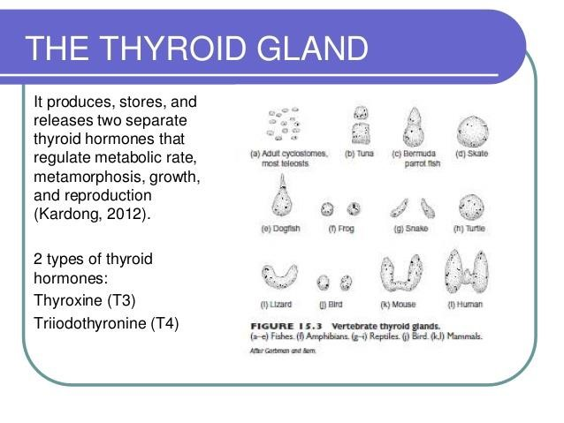

Histology
- Composed of a large number of follicles
- Each in the form of a hollow ball- consisting of a single layer of epithelial cells enclosing a fluid filled spaces
- Follicles vary in shape and size- bound together by connective tissue
- Highly vascular and surrounded by epithelial cells
- Height of the epithelial cells depends on secretory activity

2 type of epithelial cells
- Chief cells- columnar in shape
- Benstay’s cell or colloid cels – contain droplets of secretions
- Lumen of each follicle contain acidophilic or basophilic colloiddepends on secretory activity

Thyroxine
- Iodinated derivative of tyrosine
- Production is under the control of thyrotropin from AHP
- Osmoregulation, nitrogen metabolism, migration carbohydrate metabolism, scale and bone formation, growth and feeding
- Thyroid hormone acting up on cerebral centers- increases sensitivity of olfactory centre- evoke normal feeding in fishes

3. Adrenal gland
- Adrenal cortex and adrenal medulla separately found in fishes
- In cyclostomes, adrenal cortex occur in the wall of cardinal veins
- In elasmobranchs, located between posterior lobe of kidney
- In bony fishes, in the cardinal veins
- In dipnoi, ventral surface of kidney
- Adrenal cortex or Interrenal tissue produces adrenocorticosteroid hormones
- Mineral corticoids- control osmoregulation
- Glucocorticoids- control metabolism of proteins and carbohydrates, antiinflammatoryreaction
- aldosterone- regulate Na level
- Cortisol
- Cortisone
- Corticosterone- protein and carbohydrate metaboilsm
-unde the control of ACTH of hypophysis
- Adrenal medulla or chromaffin tissue or suprarenal bodies
- In lampreys- in the form of strand along dorsal aorta
- In shark- associated with nerve ganglia
- In elasmobranchs- true adrenal position
- Produce adrenaline and noradrenaline
- Increase blood sugar content in times of sudden demands

4. Corpuscles of stannius
- Small nodular bodies attached with kidney
- Oval or round in shape – 0.15-6 mm in size
- In shark , flat white structure on the peritoneal surface of kidney
- Pink or white in colour , 1-10 in number
- Originated as outgrowth from the pronephric or mesonephric region
- Histologically an outer capsule of firous tissue and inner mass of columnar cells
- Renin regulate bp, osmoregulation, control electrolyte homeostasis by regulating kidney

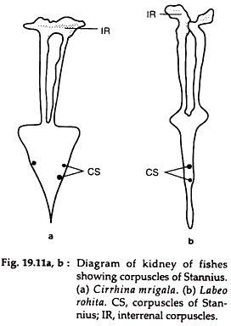

5. Ultimobranchial gland
- Exciting invention in fish endocrinology
- Absent in cyclostomes
- Described by Van Bemmelen (1886)as suprapericardial bodies
- Also known as post- branchial bodies
- Modern term by greli (1905)
- Originated from epithelium of last gill pouch
- In Elasmobranch, located in the left side of pericardium
- In Teleosts, bilateral and located in the transverse septum between abdominal cavity and sinus venosus

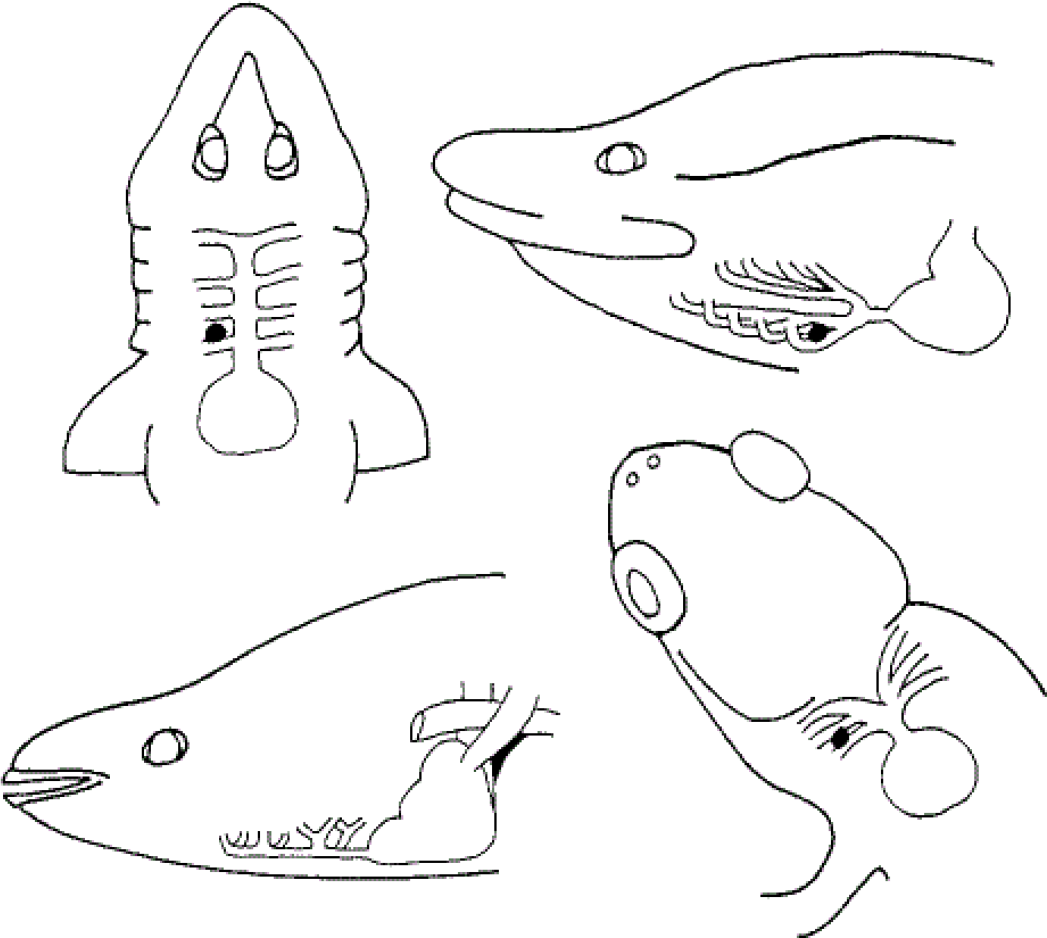

- Composed of highly vascularised follicles, lined with columnar epithelium
- Some granular materials present in the follicle
- Covered by 2 type epithelial cells – dark nucleus, numerous mc and pale nucleus, less mc
- Calcitonin – regulate plasma Ca level by bone Ca resorption
- Under the control of pituitary

6. Urohypophysis
- Urohypophysis or caudal neurosecretory organ
- Present only in Elasmobranchs and teleosts
- Is in the form of a swelling at the posterior end or caudal end of spinal cord or in the wall
- Contain neurosecretory cells
- Large sized cells with enlarged axons
- Cells bodies- Dahlgren cells – located in the grey matter
- In Teleosts, axon terminate into small bulb – which store and release secretion
- In Elasmobranchs, no bulb
- Urotensin complex contains 4 components
- Urotensin I – decrease bp
- Urotensin II – increase bp
- Urotensin III – enhance Na uptake
- Urotensin IV – increase water transfer and contract smooth muscle of urinogenital system

7. Pancreatic Islets
- Composed both exocrine and endocrine parts
- Endocrinal part represented by Islets of Langerhans – separate from the pancreas – located near gall bladder or spleen or intestine – principle Islets
- Arise from the endodermal lining of embryonic foregut
- Alpha or A cells – secrete glucagon
- Beta or B cells - secrete insulin
- D cells – function is not clear

8.Pineal Organ
- Situated nearby pituitary
- Consist of pineal sac, pineal thalamus ande pineal stalk
- Both photosensory and secretory in function
- Pineal sac- photoreceptive organ in fishes but also considered as an endocrine gland
- Gonadotropins – influence maturation of gonads
- Pinealectomy results in reduce growth rate and abnormalities in skeleton

Sex gland
- Secretion by specialized cells of ovaries and testies
- Under the control of pituitary
- Necessary for maturation of gametes & ssc- breeding tubercles and colouration
- Secrete testosterone and estrogen
- Progesterone from corpora lutea control vitellogenesis , egg capsule formation and oviposition
- Oestradiol – development and maintenance of reproductive tract
- Relaxin – egg laying

10.Intestinal mucosa
- From anterior part of the small intestine
- Under the control of NS
- Secretin – affects flow of enzyme carrying liquids from pancreas
- Pancreozymin- accelerate flow of digestive enzymes
- Pituitary gland- ACTH, Prolactin, Thyrotropins, Gonadotropins, Somatotropins, MSH, MCH, Vasopressin, &Oxytocin
- Thyroid gland – Thyroxine
- Adrenal gland – Aldosterone, Cortisol, Cortisone, Corticosterone, Adrenaline & Nonadrenaline
- Corpuscles of Stannius – Renin
- Ultimobranchial gland – Calcitonin
- Urohypophysis – Urotensin complex
- Pancreatic Islets – Glucagon & Insulin
- Pineal gland – Gonadotropins
- Sex glands- Testosterone, Estrogen, Progesterone, Oestradiol & Relaxin
- Intestinal mucosa- Secretin & Pancreozymin

Crustacean Neurosecretory system
- Nervous system & Endocrine system both work together
- Both synthesize & release special chemical agents
- Juxtacrine , paracrine, endocrine and autocrine
- Nerve cells produce materials – chemical messengers
- Locally acting or at a distance
- Many endocrine glands have a control over NS through their hormones
- Similarly endocrine organs also stimulated or inhibited NS
- Both ES & NS together is known as Neuro – Endocrine system

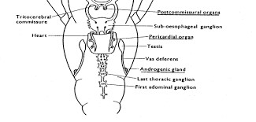

- Neurosecretory centre is found in association with optic ganglia – lies within the eye stalk
1. X- organs- best known neurosecretory centre
2 kinds – ganglionic & sensory pore
- In brachyurans , 2 X- organs fused to form to form a single structure
- In other crustaceans they are separated as group of neurosecretory cells
- Clusters of secretory neurons are found within the brain- in thoracic ganglia , esophageal connective ganglia & central commissure
- Neurosecretory cells are group of nerve cells capable of functioning as glands
- Granules of secretory nature originate in the nerve cell bodies and are moved along the axons to bulb like terminals
- Axon terminals end near blood vessels – act as storage and release centres – neurohormonal organs
- Eg:- neural lobe of pituitary, insect corpus cardiacum and crustacean sinus gland
- Neurohormones – polypeptides – chemical messengers released by neurosecretory cells
- Neurosecretory cells act as a link between CNS & endocrine organs
- Receive impulse from CNS and respond by releasing neurosecretions which stimulate or inhibit endocrine glands
2. Sinus gland – another best known neurosecretory centre – storage and discharge
- Build up of axonic ends packed in connective tissue & closely associated with rich vascular channels
- Act as reservoir for the storage & discharge of neurohormones
- Post commissural and pericardial organs – neurohaemal centersstore and discharge
- Secretion charged axons from oesophageal connective ganglia terminate in the post commissural organ
- Ventral ganglia liberate hormones to pericardial organs
- 3 Endocrine glands not composed of secretory neurons are found in crustacea
- Y organs – androgenic glands & ovaries
- Y organs – located in the antennary or maxillary segment – regulated by neurosecretion from eye stalk complex
- Androgenic gland located outside the testis , typically found along the vas deferens
- Induce primary & secondary sexual characters in male
- - controlled by neurohormones from the X -organ
- Androgenic gland hormones regulate spermatogenesis in males • Removal of AG delayed spermatogenesis
- If AG grafted into a female , ovaries transforms into testis – also appeared SSC of male
- if ovaries grafted into male without AG, they persist as functional ovaries
- When grafted into male with AG, acquire testicular structure
- In the absence of AG hormones , the gonad can become ovaries, but testicular differentiation requires the presence of this hormone
- Differentiation of germ cells is reversible regardless of their genetic constitution
- In hermaphrodites , AG present only during male phase of life cycle
- Reproduction is under the control of neuroendocrine system
- ovaries &androgenic glands regulate the differentiation of both male & female sexual characters
- Neurosecretion from ganglionic X organ – sinus gland complex inhibit ovarian maturation & secretory activity of androgenic glands
- Moulting hormone from Y organ is essential for normal differentiation of both ovary &testis
- Bilateral removal of ovaries in certain crustaceans result in the loss of SSC
- Removal of androgenic glands induced SSC of the female type in genetic males
- Extract of eye stalk with ganglionic X organ prevent ovarian enlargement

