FISHERY SCIENCE I

CIRCULATORY PHYSIOLOGY

Gincy C George (Assistant Professor On Contract)
CIRCULATORY PHYSIOLOGY

- Heart :-
- 2 chambered heart
- They have one atrium and ventricle
- Heart resembles the embryonic condition of all other vertebrates
- Afferent branchial arteries develop from aortic arches 3,4,5
& 6 to supply blood to the gills
- Conus arteriosus is muscular extension of the ventricle which lead into the ventral aorta
- Posterior end of the heart is sinus venosus, a thin walled space where blood from the veins gathers before entering the atrium

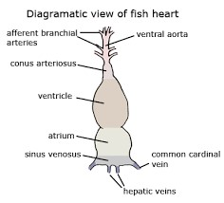
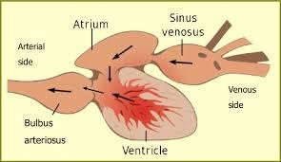

- Heart have 3 layers
1.Epicardium – outer epithelium layer
2.Myocardium – composed of straited muscle ( inner spongy & compact)
3.Endocardium – blood vessels & nerves areb present
Shape of the heart:-
- Ventricle have pyramid shape in active swimming species, eg:- salmonids
- Others are elongated , tubular ,or rounded

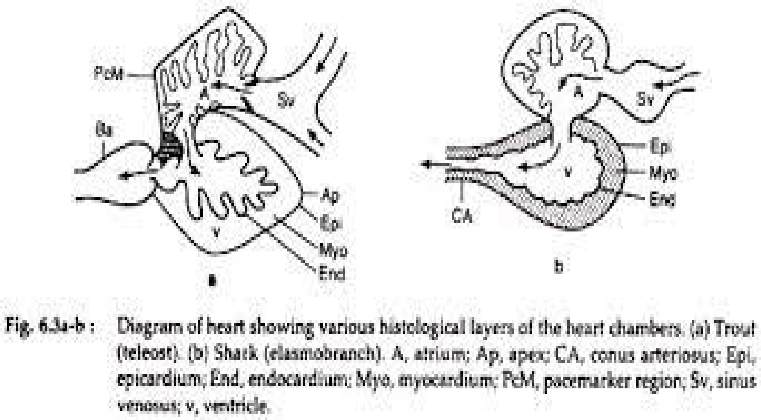

The fish heart -pump
- The heart is pump that generate the driving pressure for the circulation of blood ( arterial pressure)
- 2 chambered heart- 1 atrium & 1 ventricle, 2 other chamber – sinus venosus & bulbus arteriosus
- Blood from the body , which is low oxygen enter atrium via sinus venosus, which contain pacemaker cells initiate the contraction
- Then pumped into ventricle from atrium ( thin walled muscular chamber)
- Blood pumped into bulbus arteriosus by the ventricle ( thick walled) chamber with cardiac muscle
- Ventricle is responsible for the generation of blood pressure
- The last chamber, bulbus arteriosus reduce blood pressure
- After BA, are the gill organ ( thin walled & may be damaged)
- BA contain elastic components

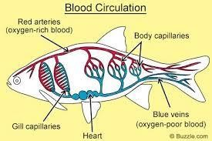

- Heart is composed of typical vertebrate cardiac muscle
- Cholinergic fibers innervate the heart except in hagfish which have aneural heart (fish lack sympathetic innervation)
- In fishes, the heart only has 1 atrium and ventricle
- Oxygen depleted blood returns from the body enters atrium ventricle gills body
- Atrium collects blood that has returned from the body pass to the ventricle and they enter into the gills where gas exchange occur & blood re-oxygenated ( gill circulation)
- Blood then continues through the rest of body and pass to the atrium ( systemic circulation)
- Function of circulation :- distribute nutrients, oxygen and hormones and remove the metabolic wastwe which are carried to excretory organs
- Veins or arteries has 3 layered
- Outer layer is Tunica adventia – connective tissues
- Middle – Tunica media – connective tissues & muscle – absent in some veins
- Inner layer is Tunica intima- endothelium

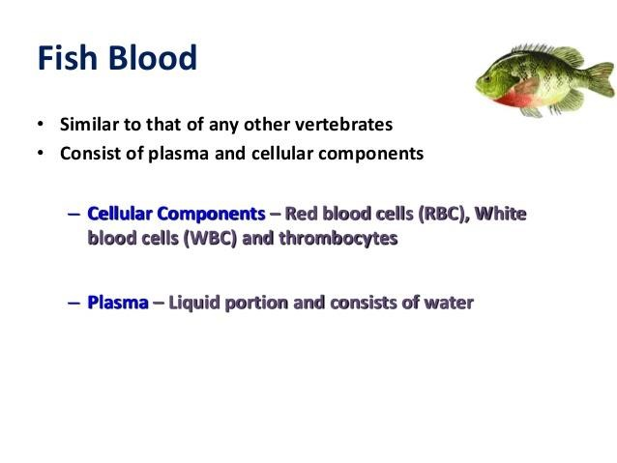

Blood composition of fish
- RBC
- WBC
- THROMBOCYTES
*Plasma :-
- Plasma consist of water – it act as solvent –lymph is the part of plasma
- The marine teleosts in polar, contain antifreezing protein (AFP) / Antifreezing glycoprotein(AFGP)
- Plasma contain albumin- control osmotic pressure
- It contain lipoprotein- to transport lipids
- Ceruloplasmin- copper binding protein
- Fibrinogen & iodurophorine
- Total plasma protein in fish- 2-8g/d
- T3 & T4 present – thyroxine bind to vitellogenin in several cyprinid species

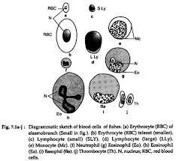
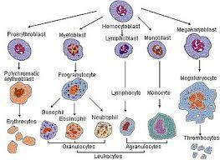

- RBC:-
- RBC cytoplasm coppery purplish , coppery pinkish or light bluish in indian fresh water teleosts
- Mature erythrocytes contain abundant haemoglobi and are pink / yellowish on preparation stained with Giesma
- Cytoplasm take eosin stain due to haemoglobin and basophilia due to staining of ribosomes
- Double staining cell- polychromatophilic erythroblastreticulocytes
- In adult teleosts, immature red cells – Proerythrocytes present- it varies species as well as the age of individual, season and environmental conditions
- Nucleus is round / oblong in shape
- Larger in elasmobranchs
- Brackish water species have smaller blood cells than FWF
- Erythrocytes smaller in active species
- In deep sea teleosts, size of RBC larger
- Clarias batrachus– round shape , Labeo rohita- oval /oblong
- WBC:-
*Agranulocytes – no granules, unlobed
1. Lymphocytes – numerous type, round/oval shape, rich in chromatin
Function- produce immune mechanism by the production of antibodies, T&B lymphocytes present
2. Monocytes – much less propotion, often absent in few fishes, nucleus fairly large & varied shape
Function- phagocytic
• MACROPHAGE:- phagocytosis of RBC which undergo degradation
* Granulocytes :- granules present
- Neutrophil (5-9%)- numerouas in no., 25% of leucocytes inn brown trout , multilobed shape of nucleus , granules pink, red, or violet in blood smear
- Eosinphils- low percentage
- Basophil:- round/ oval, absent in anguilled and place
• THROMBOCYTES/ SPINDLE CELLS – - 82% of WBCin herring
- Round, oval/ spindle shaped cells
- .7% in other teleosts
- Helped to blood cloting
haemopoiesis
- Spleen, lymph nodes and many organs are blood forming sites
- In elasmobranchs, erythrocytes& granulopoietic tissues are produced in the organ of Leydigs, epigonal organ and kidney
- If spllen, removed , Leydig take over RBC production
- In teleosts, both RBC & granulocytes are produced in kidney ( pronephros ) and spleen
- Spleen – red outer cortex- & white inner pulp medulla
- In RBC, thrombocytes are made from cortex
- Granulocytes from medulla
- In bony fishes( actinopterygii) RBC destroyed in spllen
- In Chondrichthyes anf Lung fishes, intestine spiral valve – WBC production
- Function of blood cells:-
- Respiration
- Nutrition - Excretion
- Haemostasis
- Hormones transport
- Humoral agent

