BIOCHEMISTRY AND CYTOGENETICS
CARBOHYDRATES
Gincy C George (Assistant Professor On Contract)

CARBOHYDRATES
- Carbohydrates are commonly called saccharides and it comes from a Greek word sakcharon, which means “sugar”.
- Compounds containing carbon, hydrogen and oxygen in which hydrogen and oxygen are present in the ratio 2:1 even some contain nitrogen, phosphorus, or sulfur.
- General formula of carbohydrate is (CH₂O)n
- But all compounds with H & O in the ratio 2:1 may not be carbohydrates, like acetic acid (CH₃COOH), lactic acid(CH₃-CH-OH-COOH)
- Even all carbohydrates may not contain H & O in the ratio 2:1, eg: rhamose C₆H₁₂O₅
- There are three major classes of carbohydrates: monosaccharides, oligosaccharides, and polysaccharides
- Monosaccharides, or simple sugars, consist of a single polyhydroxy aldehyde or ketone unit.
- Most abundant monosaccharide is the 6C sugar D-glucose, sometimes referred to as dextrose
- Monosaccharides are colorless, crystalline solids that are freely soluble in water but insoluble in non-polar solvents.
- Most have a sweet taste. The backbones of common monosaccharide molecules are unbranched carbon chains in which all the carbon atoms are linked by single bonds.

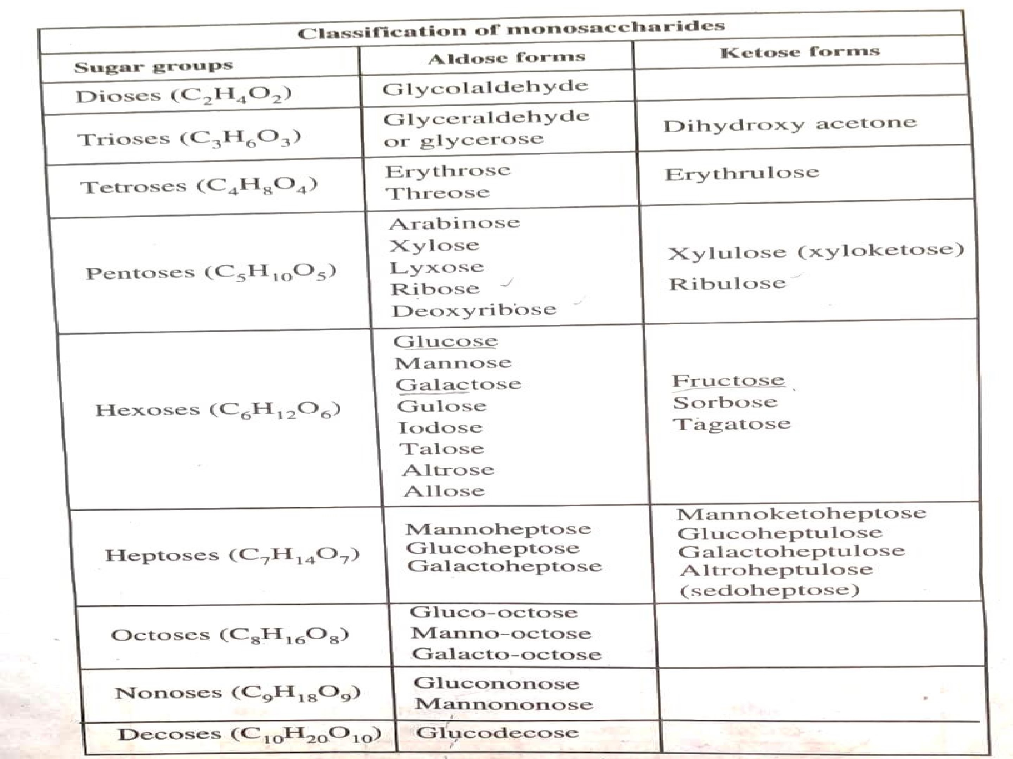

- In the open-chain form, one of the carbon atom is double-bonded to an oxygen atom to form a carbonyl group (reducing group); each of the other carbon atoms has a hydroxyl group.
- If the carbonyl group is at an end of the carbon chain (that is,the aldehyde group) the monosaccharide is an aldose; if the carbonyl group is at any other position (ketone group) the monosaccharide is a ketose.
- Carbohydrates are hydroxy aldehydes or ketones i.e they are polyhydroxy aldehydes or polyhydroxy ketones
- The simplest monosaccharides are threecarbon trioses: glyceraldehyde, which is an aldotriose, and dihydroxyacetone, a ketotriose
- They are called reference molecules
- Most common monosaccharides in nature are glucose and fructose
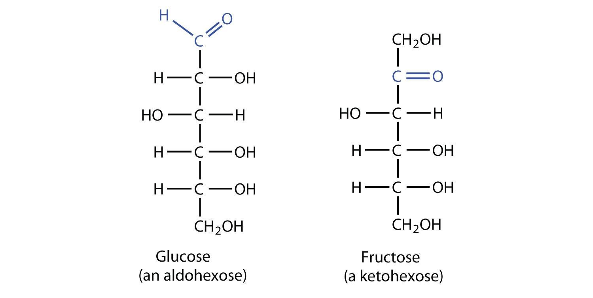
Open chain structure of glucose & fructose
- Monosaccharides with more than 4 C atoms can exist in the form of a ring structure in aquous solution
- H E Fischer proposed the existance of monosaccharides in the form of a cyclic structure in aquous solution such that carbonyl group has forms a covalent bond with the oxygen of a hydroxyl group
- The formation of these ring structures is the result of a general reaction between alcohols (hydroxyl group)and aldehydes or ketones (carbonyl group) to form derivatives called hemiacetals or hemiketals
- This leads to formation of asymmetric carbon atom with formation of 2 stereoisomers
- Here, OH of the 5th C atom make a bridge with O of 1st C atom, OH is transferred to 1st C atom making it asymmetric
- As a result 2 stereoisomers of glucose are formed- α- glucose and β- glucose
- These are called anomers of glucose
- If OH is on the right side, it is called α-glucose and if OH is on the left side, it is called β- glucose
- In case of fructose, only α anomer is possible
- It is because, the carbonyl group is present in the 2nd C atom, and 1st C is not vacant, so rotation is not possible
- In case of glucose, carbonyl group is present in 1st C atom, so rotation possible, and 2 anomers present

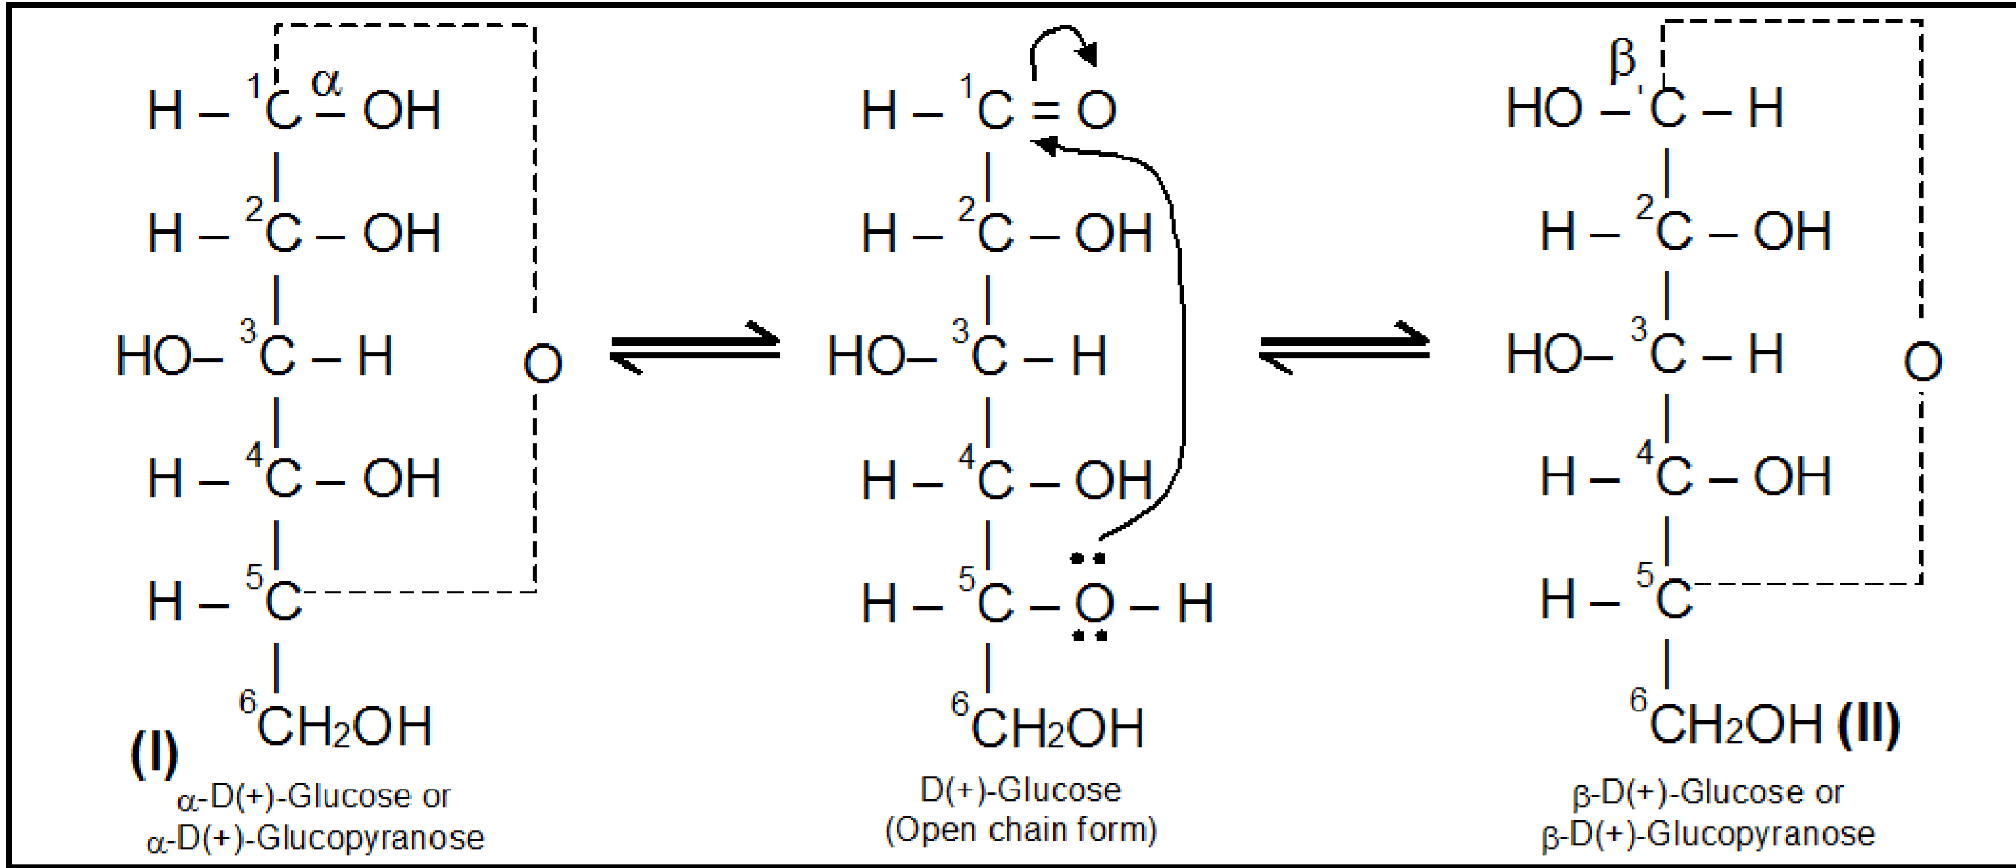

- Walter Haworth also showed the existance of monosaccharides in the form of a ring structure when dissolved in water, it can be in the form of pyran ring or furan ring
- Sugar forming pyran ring- pyranoses
- Sugar forming furan ring- furanoses
- Glucose and fructose can exist in both pyranose and furanose form
- Stable form of glucose is pyran ring form and that of fructose is furan ring form

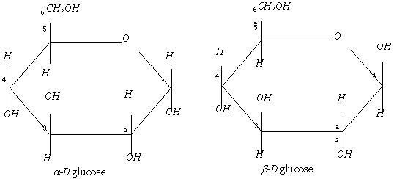
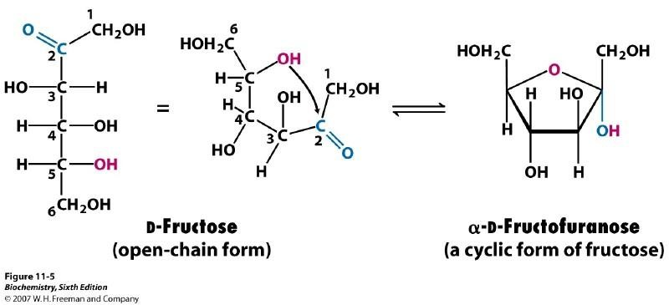

PROPERTIES OF MONOSACCHARIDES

ISOMERISM
- Phenomenon in which compounds have same emperical formula and elemental
composition, but different structures is called isomerism
- 2 types of isomerism; structural isomerism and stereo isomerism

• Structural isomerism
- Phenomenon in which molecular formula of the compounds are same but have different structures
- Eg: glucose and fructose
- Ethyl alcohol (CH₃ CH₂ OH)and dimethyl ether (CH₃-O-CH₃)

• Stereo isomerism
- Phenomenon in which molecular formula as well as the groups are same, but spacial arrangement of the group are different
- Stereo isomerism are of 2 types:
- Geometrical isomerism
- Optical isomerism
- Geometrical isomerism/ cis-trans isomerism
- This type of isomerism arise due to restricted rotation about the double bond
- Eg: maleic acid and fumaric acid
- In maleic acid, H and COOH are on the same side, but in fumaric acid COOH group is arranged on opposite side
- 2 C atoms are linked by double bond, so free rotation is not possible
- Maleic acid is called cis- isomer and fumaric acid is called trans- isomer
- Optical isomerism
- It arises due to chirality of the C atom
- The presence of asymmetrical C atom causes optical activity
- Asymmetrical C atom or chiral C atom- Catom attached to different groups
- Eg: D- glyceraldehyde and L- glyceraldehyde
- They are mirror images of each other, each compound is called enantiomer of the other
- Epimerisation
- Epimer- variation in the H and OH in any one of the asymmetric C atom other than carbonyl carbon is called epimers
- Eg: mannose is the 2nd epimer of glucose, Galactose is the 4th epimer of glucose
- Process by which one epimer is converted to other in presence of the enzyme epimerase, is called epimerisation
- Eg: conversion of glucose into galactose and viceversa takes place in liver tissue

• Mutarotation
- Mutarotation is the change in the optical rotation
- Anomers of D-glucose (α- D glucose and β- D glucose) interconvert in aqueous solution by a process called mutarotation.
- Mutarotation was discovered by French chemist Dubrunfaut in 1846

